Proposal stage
COS 435 Course Project

Subject: Large-Scale Auction Challenge: Learning Decision-Making in Uncertain and Competitive Games

Goal: decide the best bid for an impression opportunity

Links:
- Data & competition general track baseline: https://github.com/alimama-tech/NeurIPS_Auto_Bidding_General_Track_Baseline
- Synthetic data benchmark: https://github.com/alimama-tech/AuctionNet
- Competition web page: https://tianchi.aliyun.com/competition/entrance/532226
- Proposal (overleaf): https://www.overleaf.com/6758815738rzksmxrfkdgn#494d87 (our deliverable for Mar 20, 2026)
- Winning team’s presentation (general track): https://neurips.cc/virtual/2024/109208
- A potential starting point (OIL):
  - https://arxiv.org/abs/2412.11434
  - https://github.com/sony/oil

Proposal Grading rubrics:
- 1a/ Project proposal (12%). Does the proposal use the provided template and answer all the questions therein?

IDEAS for deliverables:
- An algorithm with better …
  - Training stability
  - Sample efficiency
  - Final testing score
  - Etc.

Plan
Existing baselines:
- AuctionNet baselines https://github.com/alimama-tech/AuctionNet
- IQL, Behavior Cloning, BCQ, TD3-BC, Online LP, Decision Transformer

Baselines to implement:
- PPO (our focus — and its modifications): we may consolidate OIL baseline
  - After PPO: add things to PPO (not introducing new RL baselines)
- LLM finetuning (best if w/ RL training)

Week (Apr 3 – Apr 7):
- Implement PPO and visualize the training process (Ruirong Feng, before Tuesday)
- AuctionNet baselines & visualization (Andrew Liu)

Dev Logs
PPO bidding strategy
- Training: two-stage
  - 1st: behavior cloning for warm-up
  - 2nd: PPO training with offline data fed by a simulator (as if it is online & on-policy)
  - 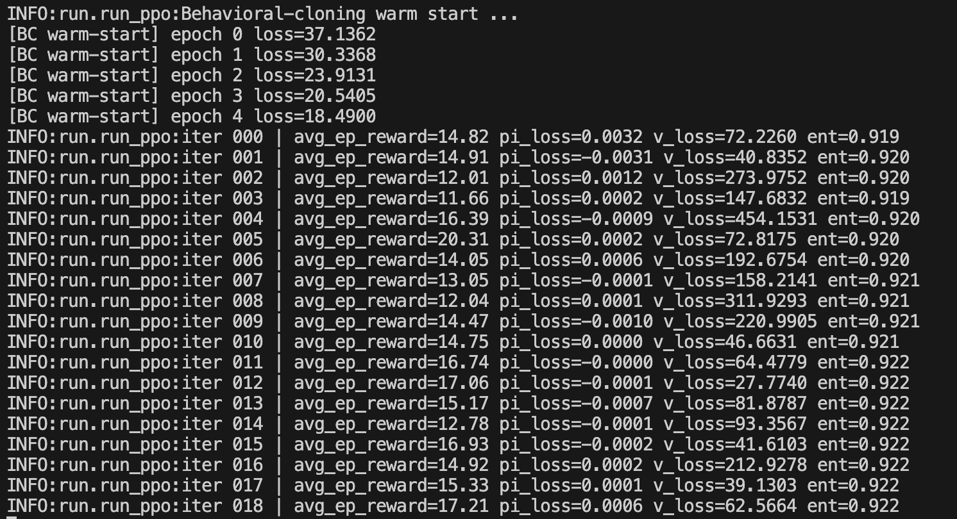
- Evaluation:
  - Fixed policy from pretrained model
  - Kept this way for fairness — other models are pretrained
  - We should use episode 7-26 for training, episode 27 for evaluation, aligning with OIL implementation

Side Notes
Currently the baseline is not so good, where when CPA goes above there is penalty but not

Baseline Results
Add baseline results in the following format:
BEGIN
Method: [method]
- Training data: [period-{x} to {y}]
- Testing data: [period-{x}]
- Data preprocessing techniques: [e.g., number of dimensions of features, etc.]
- Learning rate: [lr: float]
- Number of steps trained: [n_steps: int]
- Training visualization (if any, incl. Score / Ep. reward / Loss / Entropy plots): [image #x]
- Other important metrics / comments
END

—---------------------------------------------------------------—--------------------------------------------------------------------------------------------------
PLEASE ADD RESULTS BELOW
—---------------------------------------------------------------—--------------------------------------------------------------------------------------------------

Method: [IQL]
- Training data: [period-{13} to {15}]
- Testing data: [period-{7}]
- Data preprocessing techniques: [e.g., number of dimensions of features, etc.]
- Learning rate: [lr:1e-4]
- Number of steps trained: [n_steps: 20,000]
- Training visualization (if any, incl. Score / Ep. reward / Loss / Entropy plots):
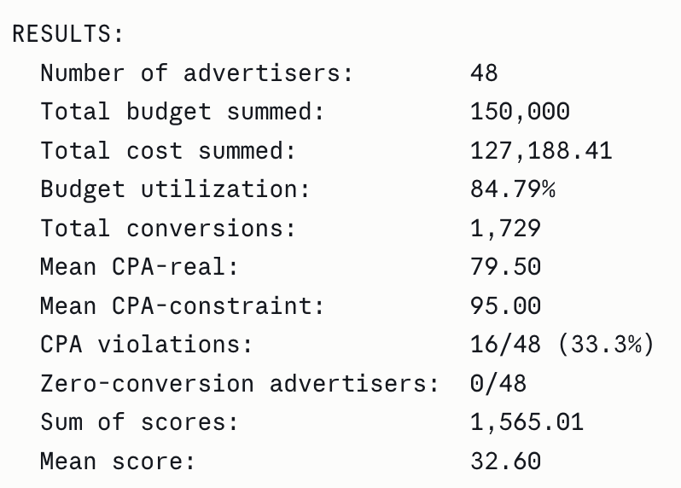
- Other important metrics / comments

